***A Mini Project Synopsis on***

# APSIT MUSIC ZONE

**T.E. - I.T Engineering**

**Submitted By**

**Kunal Palande (20104031)**

**Aaswit Kanhed (20104083)**

**Nishant Palav (20104055)**

**Under The Guidance Of**

## Prof. Roshna Sangle



**DEPARTMENT OF INFORMATION**

**TECHNOLOGY**

## A.P. SHAH INSTITUTE OF TECHNOLOGY

G.B. Road, Kasarvadavali, Thane (W), Mumbai-400615

UNIVERSITY OF MUMBAI

**Academic year: 2022-23**

## CERTIFICATE

This to certify that the Mini Project report on **APSIT MUSIC ZONE** has been submitted by Kunal Palande (20104031), Aaswit Kanhed (20104083), and Nishant Palav (20104055) who are the students of A. P. Shah Institute of Technology, Thane, Mumbai, as a partial fulfilment of the requirement for the degree in Information Technology, during the academic year 2022-2023 in the satisfactory manner as per the curriculum laid down by University of Mumbai.

## Prof. Roshna Sangle

**Guide**

## Prof. Kiran Deshpande Dr. Uttam D. Kolekar

**Head of Department of Information Technology** **Principal**

**External Examiner(s):**

**1.**

**2.**

**Place:** A. P. Shah Institute of Technology, Thane

**Date:**

2

## ACKNOWLEDGEMENT

This project would not have come to fruition without the invaluable help of our guide Prof. Roshna Sangle. Expressing gratitude towards our HoD, Prof. Kiran Deshpande, and the Department of Information Technology for providing us with the opportunity as well as the support required to pursue this project. We would also like to thank our teachers who gave us her valuable suggestions and ideas when we were in need of them. We would also like to thank our peers for their helpful suggestions.

## 

## ABSTRACT

The main aim of developing this music zone (Apsit Music Zone) web application is, it’s a collection of MP3 songs in one place where users can play and listen the songs on our website at free of cost, also to provide user friendly tool for music web sites. This is one type of online music player. Most of the websites now a day’s Music products through online but download music files with free of cost makes problem with piracy so this is the best place to stop music piracy over the internet. Here the customer should log in through Music store website and play & Listen selected music files like songs, and private albums. Then selected music files can be downloaded directly to the local system of the customer. The main advantage is it is user-friendly, provide us 24 hours customer service, and decrease the manual efforts and Time.

### TABLE OF CONTENTS

1. Introduction………………………………………………………………………6

1.1.Purpose...........................................................................................................7

1.2.Problem Statement……………………………………………………….....7

1.3.Objectives......................................................................................................8

1.4.Scope..............................................................................................................9

1. Literature Review………………………………………………………………..10
2. Proposed System………………………………………………………………...11

3.1.Features and Functionality…………………………………………………11

1. Requirements Analysis.........................................................................................12
2. Project Design.......................................................................................................14

5.1.Use Case diagram………………………………………………………….15

5.2.DFD (Data Flow Diagram) ………………………………………………..16

5.3.System Architecture………………………………………………………..18

1. Technical specification……………...…………………………………………...19
2. Project Scheduling.................................................................................................19
3. Implementation…………………………………………………………………..19
4. Result and Discussion……………………………………………………………20
5. Conclusion and Future Scope................................................................................22

References……………..........................................................................................23

**Chapter No: 1**

**INTRODUCTION**

Our Project is Apsit Music Zone which is a music player application where user can listen unlimited songs for free. The problems identified was Users can’t listen uninterrupted music as per their choice. Some applications have lot of advertisement which can be tedious for the users to listen music ad free. So the solution we proposed with this project is that the application is very convenient. The users can listen their favourite music whenever they want i.e. they can access out application 24/7. The next benefit is it is very cost-effective, it will save the users efforts as we have a very simple graphical user interface as well as we provide variety of content in this easy to use Apsit Music Zone – Your favourite destination for your favourite music.

6

**Objectives**

* **To build a user friendly web application**
* **To listen add free songs whenever you want**
* **To have easy access of your favourite songs**
* **To create a better music app clone like google play, Spotify , gaana, amazon music, etc.**

**Scope**

* To reduce user’s searching time and effort.
* To provide a wide collection of music.
* Anyone can listen to our application like college faculties and students.
* Users can create their own profiles and add songs according to their choice.

**Feature /Functionality**

* Provision to play all kind of mp3 songs widely listened all over the world.
* Create, save and modify playlists as the users want.
* View the music library sorted by various aspects such as Artists, Album, Genre, Song Title, etc.
* Easy and Simple User Interface.
* Wide Songs availability since late 90’s to till current song.
* Provides relaxation to the users and help them to reduce their daily life stress and chill out listening some music in their me time.

**Chapter No: 2**

**Literature Survey**

This quarterly column offers reviews of free and fee-based music resources in a variety of digital media, including CD-ROM products, World Wide Web sites, online subscription services and databases, and music-related software of any kind. Some reviews may cover a number of related sources together. Excluded from this column are reviews of media in purely digital audio format that would normally be reviewed as sound recordings. The dates of access for each review of an online source indicate the dates during which the reviewer was evaluating the resource. All Web sites were last accessed to verify availability on 25 May 2012. The last fifteen years have been a period of massive change in the music industry. Although individuals had been sharing music for decades, the proliferation of relatively high quality compressed audio formats and mainstream peer-to-peer networking services—beginning with Napster— marked a completely new era and a clear need for new business models. While most individuals were willing to admit that simply giving copies of copyrighted music away presented a problem, by the time Napster had been shut down, the situation had already changed; listeners now believed that the cost of music had become too high given how simple distribution seemed. In response to Napster and its many successors, new business models popped up far and wide. The founding of Pandora Media in 2000, Rhapsody in 2001, Audioscrobbler and Last.fm in 2002, and Apple's release of the iTunes Music Store in 2003 were among the most important steps toward the realization of a new market system. Though heated discussion continues about whether an ownership model or a licensing model is better for artists, distributors, and consumers, the staggering number of users of the streaming services (Pandora now boasts some 80 million users) indicates that listeners are very supportive of this approach. Founded in 2006 by Daniel Ek and Martin Lorentzon, Apsit Music Zone is a music streaming service marketed to individuals. It is billed as a "legal and superior quality alternative to music piracy," with the stated goal "to help people listen to whatever music they want, whenever they want, wherever they want." Like its peers in the streaming audio service industry, Apsit Music Zone offers a free ad-supported version and free for everyone. Apsit Music Zone is an enormously popular service with many facts, thus rendering the establishment of a scope for this review as especially important. The review will describe the content found in Apsit Music Zone's database, remark on its subscription options, report on sound quality, and expound its functionality. There will also be a report on the active community of developers creating add-ons and applications (apps) for use with Apsit Music Zone and the ever-growing mass of helpful user activity, such as playlist blogs. Apsit Music Zone's possible effects on the market and on library patrons' expectations of service and content will also be considered. I tested Apsit Music Zone using Mac OS as well as the apps for Android and iOS. Apsit Music Zone is an audio player with an experience more like iTunes than its streaming music peers. Just as iTunes is an application that runs on one's computer, Apsit Music Zone uses a downloadable client application for Windows and Mac, rather than a Web client. Once the application is installed on a computer, getting started with listening is simple. A Facebook account is required in order to sign up with Apsit Music Zone initially, but one can adjust how connected the two services are later. Apsit Music Zone automatically begins importing MP3, MP4, M4A, and M4R files on the computer, but does not immediately display them. Instead, the first impression a new user receives is what's new in Apsit Music Zone's catalog, as well as featured "Apsit Music Zone Apps"— add-ons for Apsit Music Zone. One can choose some new music from their favourite list of albums or songs.

**Literature Survey of Music System and Comparison with APSIT MUSIC ZONE**

|  |  |  |  |
| --- | --- | --- | --- |
| Year | Author | Title | Outcomes |
|  |  |  |  |
| 2006 | Daniel Ek | Pandora Music Library | Pandora is a music streaming service marketed to individuals. It is billed as a legal and superior quality alternative to music piracy. |
| 2019 | Martin Lorentzon | Spotify | Listening to music with premium features but contains ads. |

2022 Aaswit Kanhed, Free to listen application which offers you

Nishant Palav, Apsit Music Zone uninterrupted listening of music and better

Kunal Palande gui as well as billions of songs with quality.

**Chapter No: 3**

**PROPOSED SYSTEM**

* Discover new music, albums, playlists and podcasts
* Search for your favourite song, artist, or podcast
* Enjoy music playlists and an unique daily mix made just for you
* Make and share your own playlists
* Explore the top songs from different genres, places, and decades
* Find music playlists for any mood and activity
* Listen to music and more on your mobile, tablet, desktop, PlayStation, Chromecast, TV, Wear OS watch and speakers.

Chapter No: 4

**REQUIREMENT ANALYSIS**

The purpose of this report is to identify and recommend possible strategies for Apsit Music Zone to build a sustained competitive advantage in the music streaming industry. Strategic Recommendation The strategic change recommended to Apsit Music Zone is to produce original content to be made exclusively available on the Apsit Music Zone platform. This recommendation will lower Apsit Music Zone’s cost structure and increase differentiation.

SWOT Analysis

Strengths

The strengths of Apsit Music Zone are its powerful brand name, agile organizational structure, large user base, algorithms, ability to innovate, and flexible financial position.

Weaknesses

The weaknesses of Apsit Music Zone are its current licensing deals with music rights holders and lack of differentiation in music content. Opportunities Apsit Music Zone has the opportunity to differentiate its product by producing original content to be exclusively available on the Apsit Music Zone platform. Apsit Music Zone also has the opportunity to capture users in emerging and existing markets in the music streaming industry.

Threats

The threats to Apsit Music Zone include the power of music rights holders, who could increase the price of music licensing for streaming, and changes in data collection policies that could restrict Apsit Music Zone’s collection of user data. Industry The music streaming industry includes companies that provide access to extensive libraries of music over the internet on the user’s device. Companies in this industry create revenue through subscription fees and from advertisements. The music streaming industry is expected to have a compound annual growth rate of 15.4% from 2019 to 2024 (Market Line, 2020).

Industry Attractiveness

The music streaming industry is moderately attractive due to moderate competitive forces. Competition is primarily driven by the high bargaining power of suppliers, lower costs to switch for buyers, and industry rivalry. Competition is weakened by a low threat of new entrants.

Strategy and Operations Apsit Music Zone operates with a broad differentiation generic strategy by offering a wide range of music that appeals to a large market of listeners and differentiates itself by providing personalized playlists and music recommendations to users.

The company offers Apsit Music Zone Free, which is based on ad revenue, and Apsit Music Zone Premium and HiFi, which are based on subscription fee revenue. Alternative Strategic Options The first alternative strategic option for Apsit Music Zone is to lower its prices to gain new users in emerging markets. The low-cost strategy would set prices below the competition to gain market share. The second alternative strategic option for Apsit Music Zone is to make purchases music rights to make music exclusively available on Apsit Music Zone.

This option would create differentiation for Apsit Music Zone by making music exclusive to Apsit Music Zone. This report includes an external analysis, an internal analysis, and a strategic recommendation.

The external analysis will define the music streaming industry and identify the strategies of the competitors in the industry. The external analysis will also include Porter’s 5 Forces analysis and macro environmental analysis to identify the opportunities and threats present in the music streaming industry. The internal analysis will identify Apsit Music Zone’s strengths and weaknesses through a VRIO analysis, value chain analysis, and financial analysis. Finally, the report will conclude with a strategic recommendation and implementation plan based on the strengths, weaknesses, opportunities, and threats present for Apsit Music Zone and the music streaming industry.

**Chapter No: 5**

**PROJECT DESIGN**

**Flowchart**

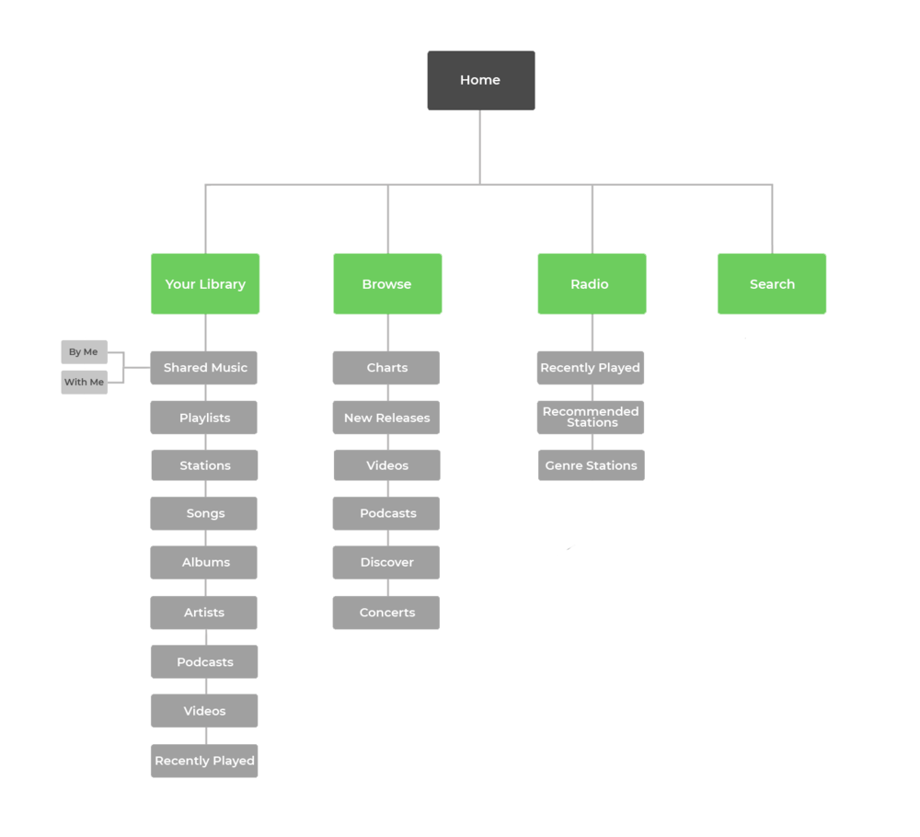

Use Case Diagram

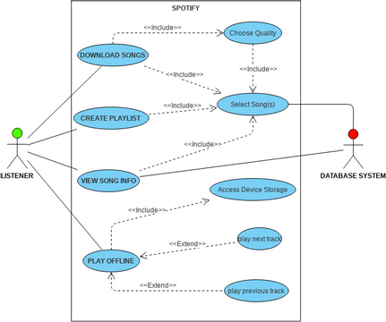

DFD – Data Flow Diagram

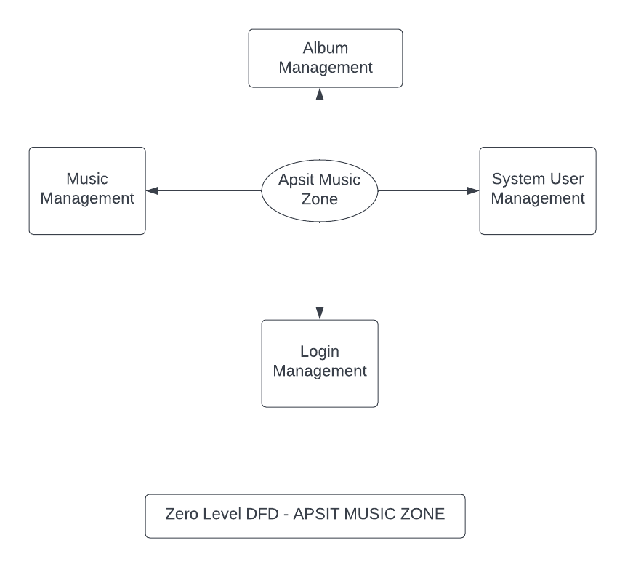

**DFD Diagram  
(Level 0)**

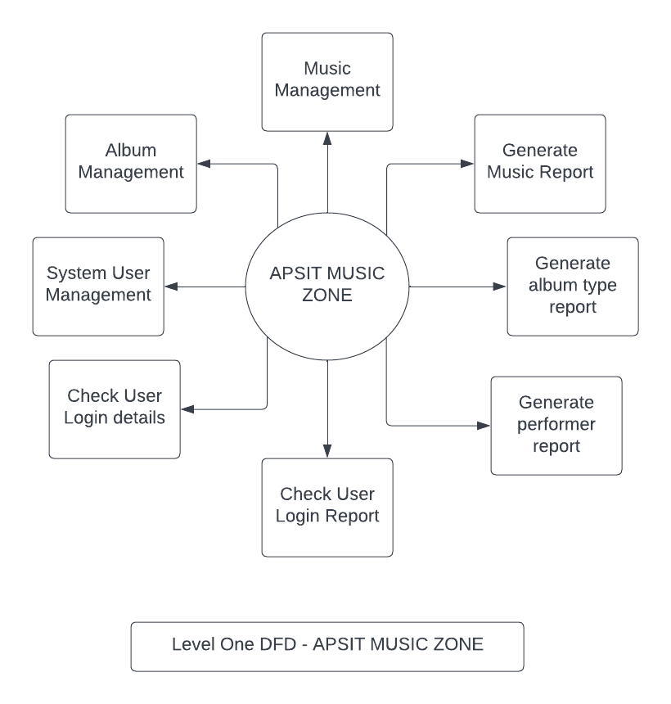

**DFD Diagram  
(Level 1)**

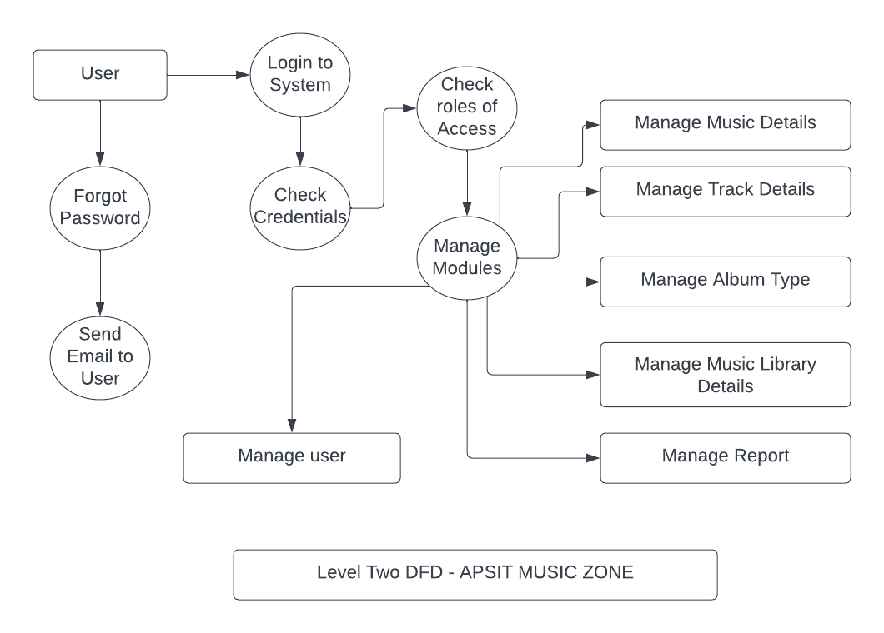

**DFD Diagram**

**(Level two)**

**Chapter No: 6**

**TECHNICAL SPECIFICATIONS**

**Development: VS Code**

VS Code also known as Visual Studio Code is a source code editor made by Microsoft for Windows, Linux, MacOS. It has various features such as Debugging, Syntax highlighting, extension, intelligent code completion.

**Frontend: Html, CSS, JavaScript**

As a web developer, the three main languages we use to build websites are HTML, CSS, and JavaScript. JavaScript is the programming language, we use HTML to structure the site, and we use CSS to design and layout the web page. These days, CSS has become more than just a design language, though. You can actually implement animations and smooth transitions with just CSS.

OS : Windows

Windows is a graphical operating **system** developed by Microsoft. It allows users to view and store files, run the software, play games, watch videos, and provides a way to connect to the internet. It was released for both home computing and professional works.

**Front-End: ReactJs**

ReactJS is an open-source, component-based **front-end** library responsible only for the view layer of the application. It is maintained by Facebook. Moreover, React Js makes Front-end development very easy.

**Firebase**

**Advantages of Using Firebase For App/Web Development**

* Real-time Database Helps to Store and Synchronize Data
* Firebase has Become Smarter with Google Analytics.
* Firebase Offers Facility of Crash Reporting to Fix Bugs Quickly
* Fast and Secured Web Hosting.
* Firebase Authentication.

**Result and Discussion**

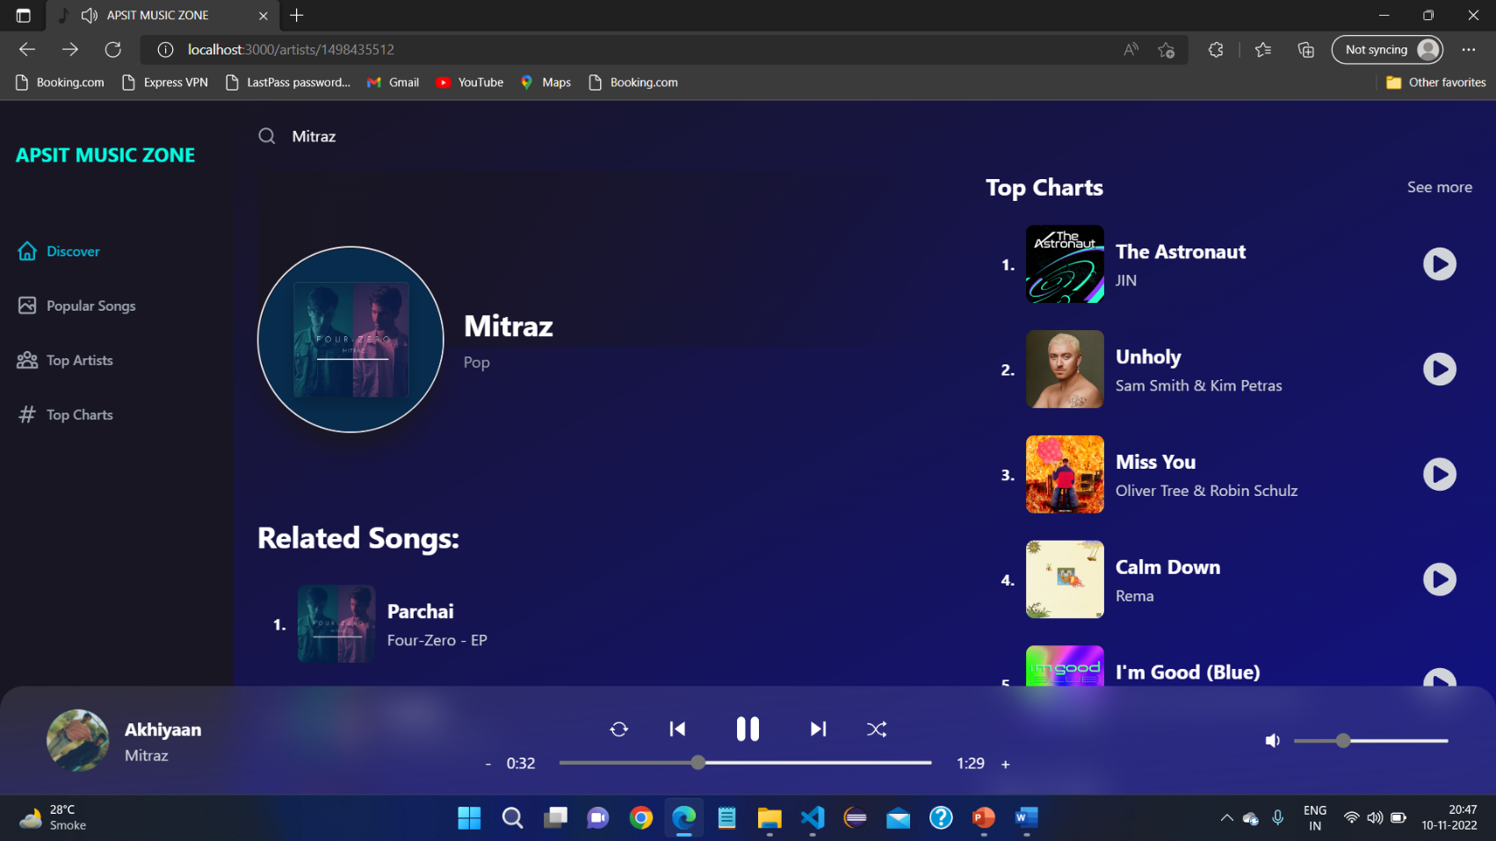

**Discover Page which allows you to search your songs, artists, etc**

**Popular Songs page where user can see the current popular songs of top artists**

**Conclusion**

* Built a user friendly music player which allows users to listen add free songs around the globe.
* Listen unlimited songs of any language without interruptions with lyrics and artist name.

**Future Scope**

* Future Scope of the Project is to add like and share feature.
* Users will able to create their own playlist and download their favourite songs.

**REFERENCES**

* [1] Cisco, Visual Networking Index Traffic and Service Adoption Forecasts, Cisco, 2016.
* [2] C. S. Jensen, M. R. Prasad, and A. Møller, “Automated testing with targeted event sequence generation,” in Proceedings of the 22nd International Symposium on Software Testing and Analysis (ISSTA ’13), pp. 67–77, ACM, Lugano, Switzerland, July 2013.
* [3] A. R. Espada, M. M. Gallardo, and D. Adalid, “A runtime verication framework for android applications,” in XXI Jornadas de Concurrencia y Sistemas Distribuidos (JCSD ’13), 2013.
* [4] A. R. Espada, M. M. Gallardo, A. Salmeron, and P. Merino, ´ “Using model checking to generate test cases for android applications,” in Proceedings of the 10th Workshop on Model Based Testing. Electronic Proceedings in Theoretical Computer Science, N. Pakulin, A. K. Petrenko, and B. H. Schlingloff, Eds., vol. 180, pp. 7–21, Open Publishing Association, 2015.
* [5] A. R. Espada, M. Mar Gallardo, A. Salmeron, and P. Merino, ´ “Runtime verification of expected energy consumption in smartphones,” in Model Checking Software, vol. 9232 of Lecture Notes in Computer Science, pp. 132–149, Springer International Publishing, 2015.
* [6] <https://www.researchgate.net/publication/254960035_Spotify_review>
* [7] <https://downloads.hindawi.com/journals/misy/2017/2012696.pdf>
* [8]<https://www.scss.tcd.ie/publications/theses/diss/2016/TCD-SCSS-DISSERTATION-2016-027.pdf>
* [9] <https://link.springer.com/article/10.1007/s11257-019-09237-4>
* [10] <https://dl.acm.org/doi/10.1145/3132498.3133836>